Measuring Module

Tape Measure
- Measure #1-7 with a tape measure and write answers in the blanks below.
- Measure #1-7 to a half (1/2), quarter (1/4, 3/4) or eighth (1/8, 3/8, 5/8, 7/8)
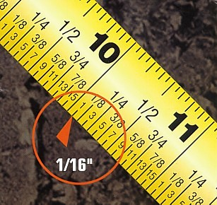
- __________

- __________

- __________

- __________

- __________

- __________

- __________

Steel Rule
- Measure #8-14 with the steel rule and write the answers in the blanks.
- Measure #8-14 to a sixteenth (1/16, 3/16, 5/16, 7/16, 9/16, 11/16, 13/16, 15/16)
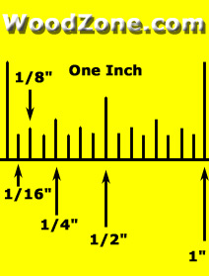
- __________

- __________

- __________

- __________

- __________

- __________

- __________

Square
- Measure #15-18 with the square and write the answer in the blanks.
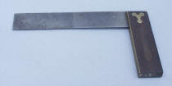
- _________

- __________
- __________
- __________

- __________

- Use the square to determine if the corners on #19-21 are square (yes) or not square (no). Circle “yes” or “no”.

- Yes No

- Yes No

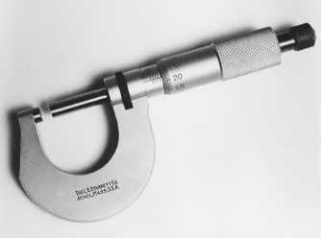
- Yes No

Micrometer

- __________

- __________
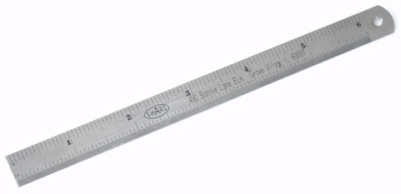
Steel Rule

- __________
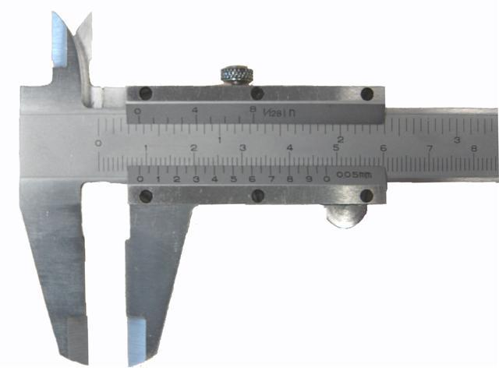
- _________

Caliper

- __________

- __________
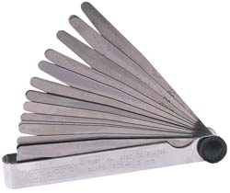
Feeler Gauges

- __________

- __________
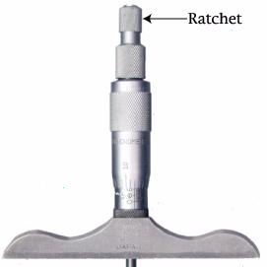
Depth Gauge

- _________

- _________
- _________

