Daniel 11
This prophecy covers the Age of the Gentiles and their interaction with Jerusalem from 536 BC up until the Lord’s return at the end of the tribulation
:1, “first year of Darius”

:2, “three more kings”

“a fourth”

“richer”
“gained power by wealth”

“stirrup . . .against
Greece”
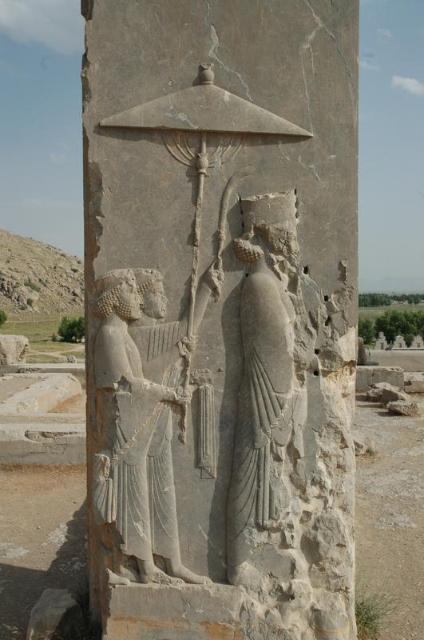
:3, “Hero-King”

:4, “As soon as he has arisen”

“empire broken up”

“four winds”

“not go to descendents”

:5, “king of south”

“commanders

“greater power”

:6, “after some years”

“daughter of the king of the south”

“given to the king of the north”

“to make an alliance”

“not retain her power”

:6, “she will be handed over”

“together with:
- royal escort
- her father
- one who supported her”

:7, “from her family line”
“arise to take her place”

“he will attack . . .king of North.

“enter his fortress”
“he will be victorious”

:8 “seize their gods, . . metal images. . .valuable articles of silver and gold and carry them of to Egypt.”

:9, “king of north will invade the realm of the king of the south.”

“retreat”

:10, “his sons will prepare for war (plural)”

“he (singular) will sweep on like an irresistible flood”

:11, king of south . . .fight against king of north”

“large army”

“it will be defeated”

:12, “filled with pride. . .
he will not remain triumphant

:13, “king of the north will
muster another army. . .

“advance with a huge army”

:14, “many rise against the king of the south

“violent men of your own people will rebel.”

“in fulfillment of the vision.”
“but without success”

:15, “king of the North”

“siege ramps and capture a fortified city.”

“forces of south will be
powerless”

“even their best troops will not have power.”

:16, “the invader”

“establish himself in the
beautiful land.”

:17, “determine to come with the might of his kingdom.”

“alliance”

“daughter in marriage”

(literally, “daughter of women.”)

“will not succeed or help him.”

:18, “turn attention to the coastlands.”

“a commander will put an end to his insolence”

“turn his insolence back upon him.”

:19, “after this he will turn back to his own country”

“will stumble and fall to be seen no more.”

:20, “His successor”

“send out a tax collector”

“in a few years he will be destroyed yet not in anger or battle.”

:21, “succeeded by a contemptible person”

“not given the honor of royalty. He will invade
the kingdom and seize it through intrigue.”

:22, “overwhelming army will be swept away.”

“both it (army) and the prince of the covenant will be destroyed.”

:23, “coming to an agreement with him, he will act deceitfully.”

:24, “when the richest provinces feel secure he will invade them.”
(KJ, “He shall enter peacefully even upon the fattest places.”)

“achieve what neither his fathers or forefathers did. He will distribute plunder, loot, and wealth.”

“Only for a time.”

:25, “against king of south”

“plots devised against him.”

:26, “those who eat. . .try to destroy him.”

“army swept away and many will fall.”

:27, “two kings”

“hearts bent on evil will sit . . .and lie.”

:28, “king of north will return. . .with great wealth
“heart will be set against the holy covenant.”

:29, “invade south again”

:30, “ships of the western coastlands “
(literally: “ships from chittim or Kittim”)
(The Septuagint simply says, “the Romans” in place of “ships of Kittim”)

“will oppose him”

“he will lose heart”

“vent fury against the holy covenant”

:31, “desecrate temple abolish daily sacrifice, set up abomination that causes desolation.”

536 BC

529
522
521

486

480

334

323

301

285

253

252

240

223

217

203

201

200

198

192

191

189

187

175

172

170

168

Cyrus was Persian Emperor in 536 when Daniel began this prophecy.

- Cambyses (529-522)
- Smerdis (522-521)
- Darius I Hystaspes (521-486, Ezra 5:6)
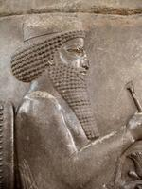

Xerxes (486-465, Ezra 4:6)
Xerxes in Esther chapter 1

Xerxes led expedition against Greece in 480.
He burnt Athens and Acropolis, but was defeated. Xerxes returned to Persia.
The empire began a downward spiral.
Xerxes was assassinated in 465

(Xerxes is followed by: Artaxerxes , Xerxes II, Sogianus, Carius II, Artaxerxes II, Ochus, Ases, and Darius III who fights Alexander.

Alexander the Great leaves Macedonia in 334 to attack the Persians. He burns Persipolis.
Alexander is “the shaggy goat” who “is the king of Greece” from Daniel 8:1. He is the large horn between the goats eyes.

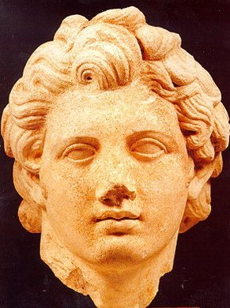
At the age of 32 Alexander died in Babylon

Daniel 8:22 says “the four horns that replaced the one that was broken off represent four kingdoms that will emerge.”

Alexander’s son Hercules was murdered at Alexander’s death.
Son Alexander II was murdered in 310 at the age of 13
General Antgonus seized Syria fromSeleucus but was finally defeated by the other four generals in 301:
- Ptolemy I – Egypt
- Seleucus I – Syria, Babylon, India
- Cassanders – Macedonia, Greece
- Lysimachus – Asia Minor, Thrace

Ptolemy I Lagus (Soter) is in Egypt
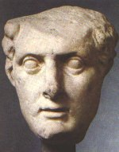
Seleucus I Nicator served as a General under Ptoley I in the war against Antigonus to regain Syria
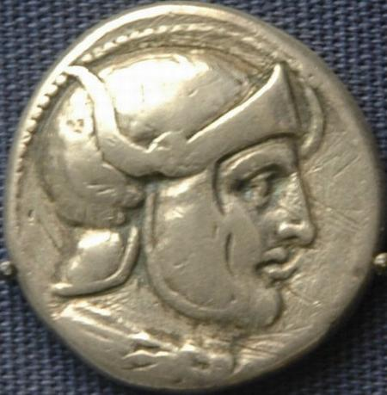

Seleucus I eventually became greater in Syria than Ptolemy I was in Egypt

The years of war between Egypt and Syria are known as the Syrian Wars

Antiochus II Theos (Syria) asked for peace
With Ptolemy II Philadelphus in Egypt.

Bernice, daughter of Ptolemy II, was given to Antiochus II Theos to marry as guarantee of the peace he wanted.
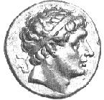

Bernice and Antiochus II had a son who was to rule Egypt and Syria when he grew up.

Ptolemy II died. Antiochus II put Bernice away and restored his first wife Laodiceia.

Laodiceia (first wife) killed:
- Bernice (Ptolemy II’s daughter)
- Antiochus II (her husband)
- Bernice and Antiochus’s son

Bernice’s brother Ptolemy III Evergetes rules Egypt
Laodiceia’s son Seleucus Callinicus took the place of Antiochus II in Syria
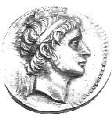

Ptolemy III attacks Seleucus Callinicus
Ptolemy takes Susa, Babylonia all the way to India’s borders

Jerome says in his commentary, “Ptolemy III attacked Laodiceia and her son Seleucus Callinicus. He abused them and took Syria, Cilicia, all Asia and beyond the Euphrates. Ptolemy then took back many of the golden Egyptian idols that had been taken from Egypt by the Persian king Cambyses”

Seleucus Callinicus mounted a return attack on Ptolemy III in Egypt

Ptolemy defeated Seleucus Callinicus who retreated.

Seleucus died in 226
Two sons: Seleucus III and Antiochus III.
Seleucus III died in battle in Asia Minor

The second son, Antiochus III the Great, began the fourth Syrian War and returned territory as far as Gaza to Syria

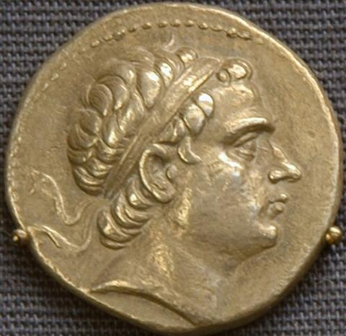

Ptolemy IV Philopator (and his sister/wife) raised a large army.
Antiochus III met this army at the Palestinian border at Raphia south of Gaza

Both armies numbered 70,000

Antiochus III the Great was completely defeated by Egypt. He was almost captured as he fled into the desert.

Ptolemy IV won the battle but only managed to secure a peace agreement. Ptolemy IV did not gain any great advantage but did briefly regain southern Syria for a while.

Antiochus III then focused on land in the East and rebuilds.

Ptolemy IV and his sister/wife mysteriously die and their 7 year old son becomes king.
He is Ptolemy V

Antiochus gained the title of “the Great” between 217-201 when he conquered in the East and rebuilt his army.

In 201 he was his opportunity and attacked the 9 year old Ptolemy V

Many people and kings challenged Ptolemy V

The Jews rebelled against Ptolemy V and opened gates for Antiochus III to enter Jerusalem. Antiochus then captures the Egyptian garrison in Jerusalem.

Ptolemy’s general Scopas retakes Palestine.

Prophecy and vision of Daniel 8 and 9 which foretold of the defeat of Jews by the coming little horn (Antiochus IV)

Antiochus III the Great

Scopas (PtolemyV’s general) was defeated at Paneas and was forced to surrender at “a city of fortification” of Sidon after it was captured by Antiochus III>

Three times Egypt tried to rescue Scopas at Sidon and failed.

Egyptian’s best generals tried to rescue Scopas: Eropas, Menacles, Damoyenus

Antiochus III

Controlled Israel setting stage for Antiochus IV

Antiochus III wanted to expand his kindom into Egypt

Through marriage of his daughter

Antiochus III made the treaty with Ptolemy V by giving his daughter Cleopatra to Ptolemy in marriage. The plan was for her son and her grandson to rule Egypt.

Cleopatra sided with the Egyptians against Syria and her father.

Rome was expanding to the East.
Antiochus III tried to move out of Asia Minor and into Greece.

Antiochus was defeated by “a commander” who was the Roman consul Lucius Scipio Asiaticus at Thermopylae

Antiochus was defeated by Scipio Asiaticus at Magnesia

Antiochus was forced to pay for the Roman expense of the war for 12 years and to give them his son Antiochus IV as a hostage.

Antiochus III had previously said at a meeting with Rome’s ambassadors that, “Asia did not concern them, the Romans, and he was not subject to their orders.”

Antiochus returned home to Syria

In an attempt to collect money to pay Rome Antiochus III was killed plundering a temple in Elam.
Seleucus IV Philopator (Antiochus III’s son) now has the responsibility of paying Rome !000 talents a year.

Heliodorus was sent to plunder the temple in Jerusalem (2 Maccabees 3:7)

Seleucus IV exchanges his sonDemetrius for Antiochus IV (his brother) who was a hostage in Rome.
Seleucus IV suddenly dies. Suspected poison

The heir to the throne was the son of Seleucus IV, Demetrius.
Demetrius had been exchanged as a hostage for Antiochus IV and was currently in Rome.
Antiochus IV assumed his brother’s position as King.

(Antiochus IV Ephiphanes is the Little Horn of Daniel 8:9-14, 23-25)
(Ephiphanes means “glorious” and was given to him by himself in line with his thinking that he was a god.)

Antiochus IV posed as the guardian of one of Demetrius but the son was murdered and Antiochus IV secured the throne for himself.

Antiochus IV Ephiphanes was successful on several occasions against Egypt.

Onias the High Priset in Jerusalem was killed by Antiochus IV Epiphanes.
He is called the prince of the covenant because he was the head of the Jewish theocracy or covenant at this time in history.

Onias opposed introducing Greek culture in Jerusalem but his brother Jason did not.
Jason would be rivaled by Menelaus.
Menelaus (tribe of Benjamin) would purchase the priesthood privileges from “Zeus Incarnate” or Antiochus Epiphanes.

Agreements with other nations where deceitful.
In Egypt his sister Cleopatra died and her two sons fought for power.

Antiochus IV supported one of Cleopatra’s sons for his own benefit.

In violation of peace treaties and alliances he attacked to plunder and rob the richest places. Even in his own land.

Antiochus Epiphanes loved power and influence and willingly gave things away inorder to win a following and bribed loyalty.

Antiochus Epiphanes is given a certain amount of time by God

Antiochus IV Epiphanes heard that Ptolemy VI was going to try to recover Syria.

Antiochus IV invaded Egypt with a large army and Ptolemy VI made peace with him.
At this time back in Alexandria, Egypt the people make Ptolemy VI’s brother King.
His name is Ptolemy VII.

Ptolemy VI’s own palace turns against him.

The result of these activities and division was more disaster for Egypt.

Egyptian Kings and Antiochus IV Epiphanes
Deception was woven into all their negotiations.

After subduing Egypt Antiochus IV will leave with great wealth.

His intentions are to use his wealth to draw Jews away from the Mosaic Covenant.

He plans to use his wealth to buy his way into a greater wealth of Jerusalem.

1 Maccabees 1:20-28 record the atrocities done to Jews as Antiochus IV marched through Judea

Antiochus IV invades Egypt again

The Fleet of Gaius Popillius Laenas arrived in Egypt having sailed form their victory in Macedonia just south of Thessalonica on June 22, 168.

Laenus came to defend Egypt from falling into Seleucid control

Laenas asked Antiochus IV if he wanted to fight or retreat. Antiochus IV said he would let him know. Laenus drew a circle around Antiochus IV and told him to make a decision before he stepped out of the circle.

Antiochus IV left Egypt in the hands of the Romans and returned to secure his borders.

2 Maccabees 5:1-22 describes his return through Jerusalem after this humiliating defeat.

Antiochus realizes he needs Jerusalem to secure the borders of his kingdom

(See Josephus Book 12 Chapter 5-6)

Verse in Daniel 11: . . . Year Historical Event

Darius I

Xerxes

Alexander the Great

Ptolemy I Soter

Seleucus I Nicator

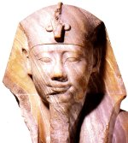

Antiochus II Theos

Ptolemy II

Seleucus Callinicus

Antiochus III the Great

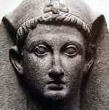

Ptolemy V

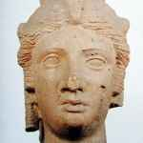

Cleopatra I

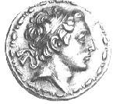

Antiochus IV Epiphanes

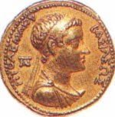

Ptolemy VI

