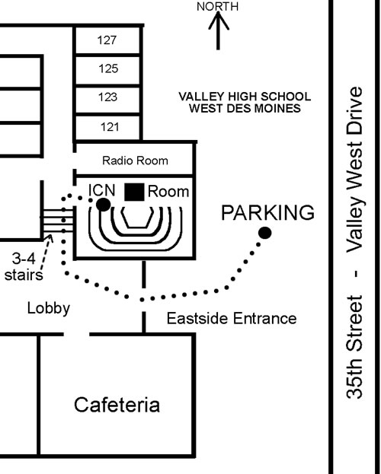
Three Weekly Bible Study Locations
#1 - Sunday Night,
7:00- 8:00 PM
Beginning on July 31, 2011
ICN Room
Valley High School
35th Street (Valley West Drive)
West Des Moines
Address: 3650 Woodland Ave

Subject:
Jerusalem and Israel. Beginning with the book - “Jerusalem: History, Archaeology and Apologetic Proof ”


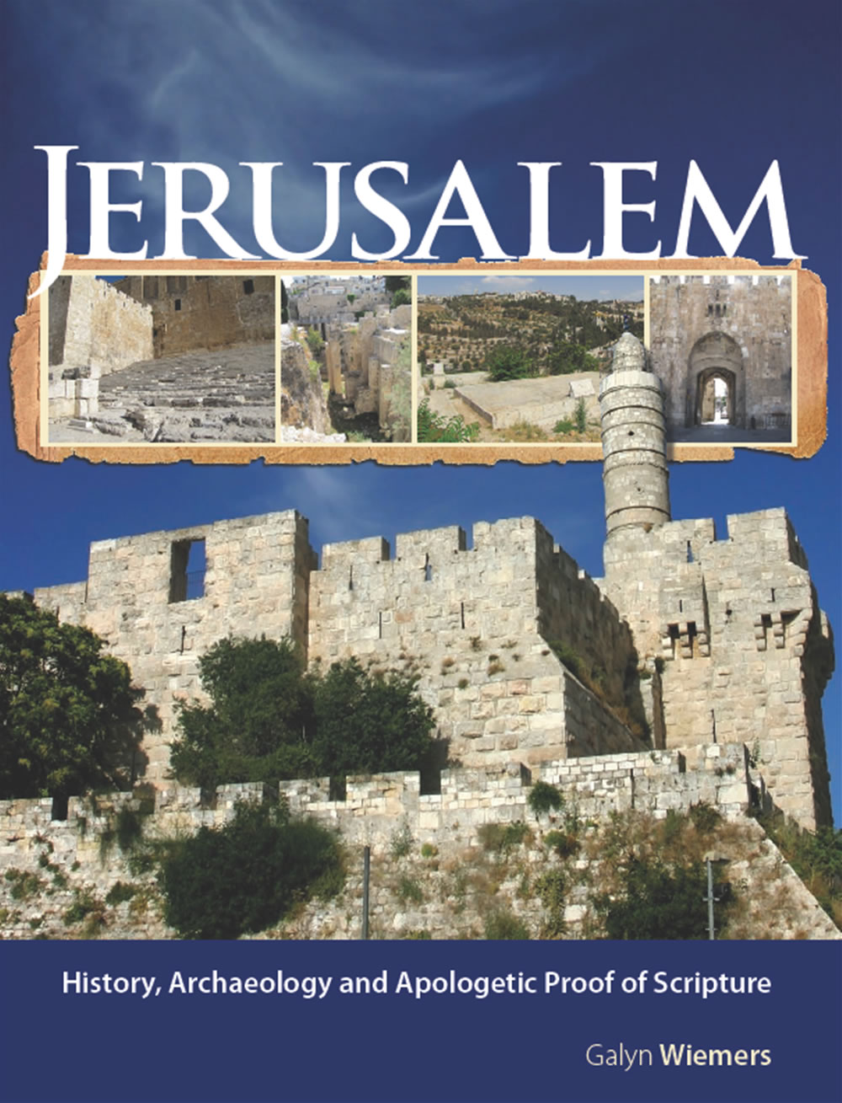

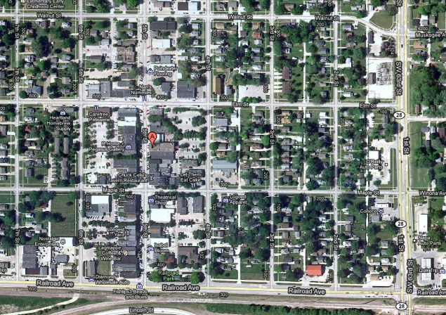
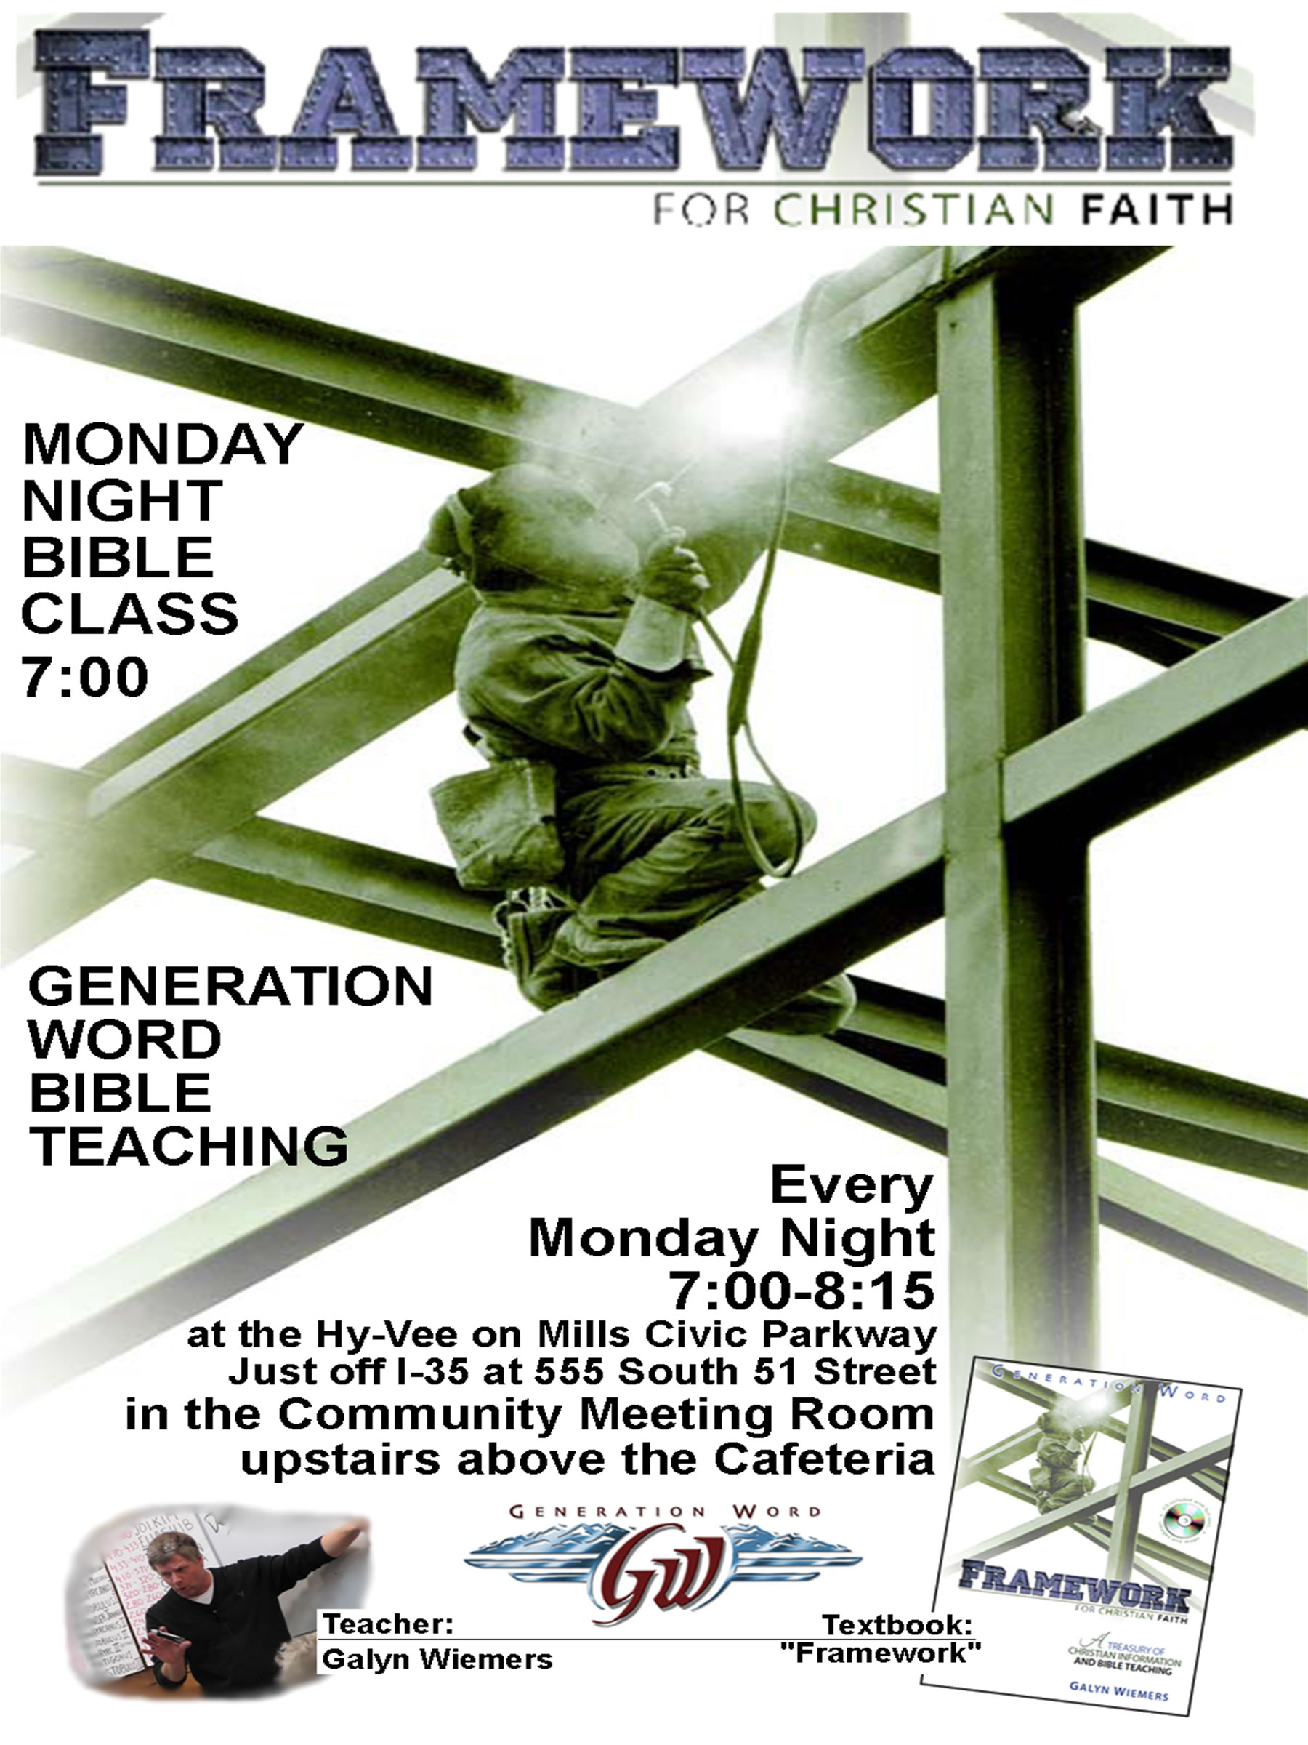
P
4th Street
5th Street
#2 – Monday Night
7:00-8:10
Every Monday Night
WEST DES MOINES COMMUNITY CENTER
217 5th Street, WDM
(Main Street of Valley Junction)

Topic:
Framework Bible School

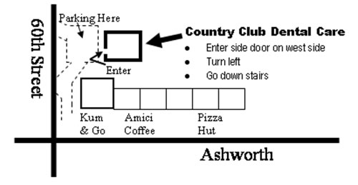
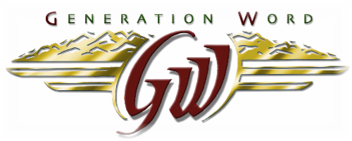
#3 – Tuesday Night
7:30-8:30
Every Tuesday Night
Basement Meeting Room below
Country Club Dental Care
Address: 1025 60th Street, WDM

Current Topic:
Verse by verse through the
book of Revelation

